Q7.Compute the misclassification error that would result if you used your clustering rule to classify the data by assigning the majority class of the cluster. (10M)

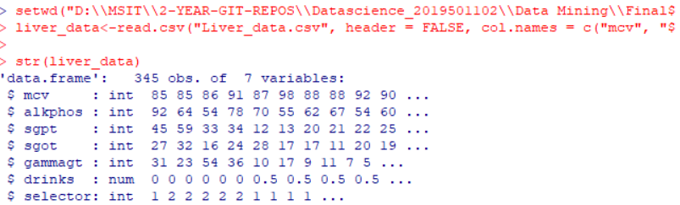

Setting the environment and dataset from liver_data website.



Taking the data into separate x and y variables.



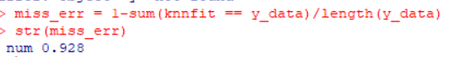



* Build model using the x variable to form a cluster of k =4
* Calculated misclassification error by taking majority of class that is y variable data.